Advice Sheet B

Providing accessible printed text

Providing accessible printed text is an important part of helping to remove barriers to learning.
General principles
One way of providing accessible text is modifying resources. There are a number of general principles to apply when producing modified materials:
- Teachers should plan ahead to make sure they/support staff have time to modify materials well before the lesson.
- If support staff are asked to modify materials, teachers need to let them know exactly what is required and by when. Support staff will need to know what information/text needs to be included so that pupils meet the learning outcome and when it will be used.
- Materials should be produced in an accessible font and size (eg Arial 14, 16 or 18 point).
- Modified print, pictures and diagrams are provided to reduce visual demand.
- Resources prepared on a computer can be saved and modified easily to produce different versions.
- Providing electronic copies of resources for pupils where appropriate means they can put them into their preferred format themselves using generic or pre-set functions on their own computers/laptops.
- Giving extra time, if needed, will mean pupils have an opportunity to process information and complete tasks.
- Looking for resources already available in a suitably modified format. Many published learning resources are already available in a modified format from the following:

Resources
Load2Learn: a free online resource/service providing accessible reading books, textbooks and images to support pupils who have difficulty reading standard print. Materials on the site can be downloaded as a PDF, audio or Word document and then adapted to meet learners’ visual needs. The service has thousands of accessible books and images in various formats – Word, audio and PDF. Subscribing settings have to agree to the rules and regulations governing the site. https://load2learn.org.uk
Blind Children UK’s CustomEyes service produces tailor-made large print books for children and young people with a vision impairment or dyslexia up to and including age 25. They have almost 4,000 large print books, with new titles being added monthly, enabling VI learners to read the same books as their sighted friends and classmates.
Books available include picture books, fiction, non-fiction, Oxford Reading Tree, GCSE and A Level English texts and textbooks, plus revision guides for Key Stages 2, 3 and 4.
The books are tailor-made to suit each pupil in their preferred:
- font
- font size
- spacing
- paper colour
- binding (for example spiral binding so books lie flat).
They supply both school libraries and local authority libraries with standard large print for their vision impaired members and can also customise large print books to suit. See http://www.blindchildrenuk.org/how-we-can-help-you/customeyes-books/how-to-join/
ClearVision: a postal lending library of over 13,000 large print children’s books. The books all have added Braille or Moon. See www.clearvisionproject.org
Free ebooks/textbooks are available online for young people with a vision impairment:
The Seeing Ear has received funding for a project to supply free books to children who cannot read normal print. The pupils might be vision impaired, or physically disabled, or dyslexic. They do not have to have an EHCP - just need to benefit from having books in an alternative format. See www.seeingear.org
Project Gutenberg has electronic texts of many books available for free download. See http://www.gutenberg.org
Calibre Audio Library provides a subscription-free service of unabridged audio books for adults and children with sight problems, dyslexia or other disabilities, who cannot read print. See http://www.calibre.org.uk/
RNIB Reading Libraries provides a wide choice of fiction and non-fiction books in audio, braille and giant print for adults and children. The library operates through a membership scheme. See http://www.rnib.org.uk/services-we-offer-reading-services/rnib-reading-libraries

Producing accessible print-based resources
When producing resources, the following factors need to be considered:
- A clear, rounded font style such as Arial, Comic Sans, or Tahoma is normally recommended for pupils with a vision impairment. Some fonts such as Times New Roman, are too embellished and do not give a strong, clear image even when emboldened. Italic styles are also not helpful.

- Good spacing makes a difference for many pupils. An increased spacing option can be created in Word 2003 by going into the paragraph option in ‘format’ and changing the single line spacing to 1.5. In Word 2007 and 2010, click on the Home tab, then expand the paragraph group (small arrow at the lower right) to find the option.
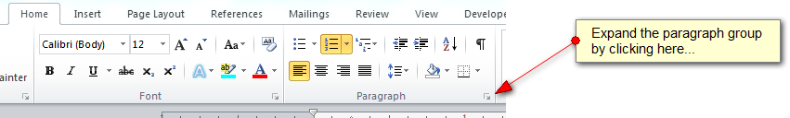
- Some pupils may even prefer a double spacing, which is also an option as this helps learners with reading difficulties discriminate letters, words and lines of text when changing the line spacing.
- Borders and shading all add unnecessary clutter. Keep the page as simple as possible.
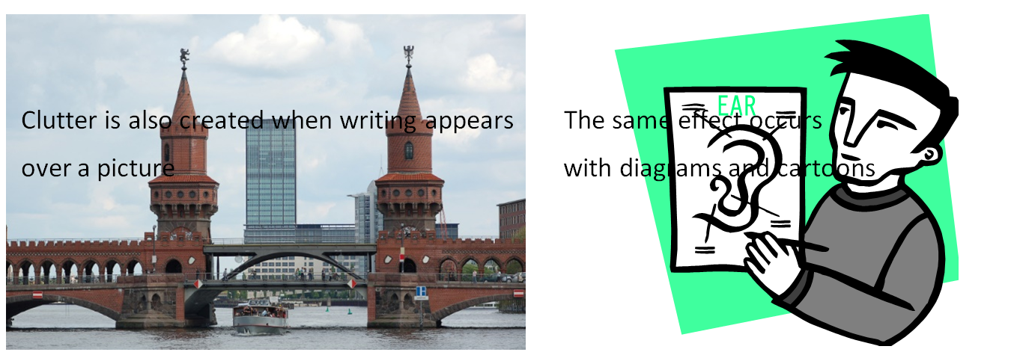

- Formatting and justification: Left-justify text with ragged right edge (like this document) so that the spacing between letters is consistent and easy for learners to track. Avoid underlining (for headings use a larger font size) and using upper case letters for continuous text. The letters can be hard to distinguish because they are all of the same height.
- Matte paper is useful: glossy paper should be avoided as this can cause distracting reflection and even glare.
- Page layout: Page design should be clear, uncluttered and free of any extraneous detail. Drawings, tables and graphs should be in bold and relevant to the text.
- Contrast between print and background: Black text (emboldened when necessary) on a cream or white background is commonly the most effective combination. Insufficient contrast makes text harder to distinguish. Arranging text over illustrations should be avoided.

